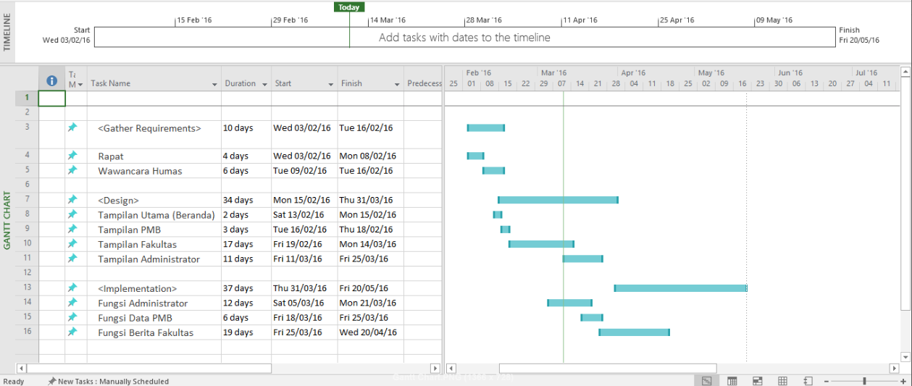**2.5.4 Review And Finalize Gantt Chart**